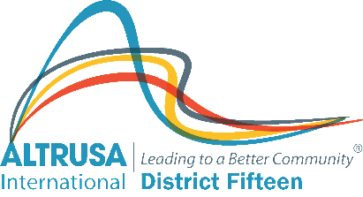

BIOGRAPHICAL FORM

TO ACCOMPANY NOMINATION FOR DISTRICT OFFICE 2023 – 2025

NAME:

ADDRESS:

TELEPHONE & E-MAIL:

CLUB:

CLUB ADDRESS:

YEAR JOINED ALTRUSA:

CAREER/PROFESSION:

DISTRICT OFFICES HELD: (please state position held and time in office):

CLUB OFFICES HELD: (please state position held and time in office):

DISTRICT COMMITTEE CHAIRS HELD:

CLUB COMMITTEE CHAIRS HELD:

OTHER ALTRUSA RESPONSIBILITIES: (name of organisation(s)):

IFF DAYS ATTENDED: (number only)

CONFERENCES ATTENDED: (number only) CONVENTIONS ATTENDED:

ANY OTHER COMMENT / INFORMATION:

